**Graphs 7**

**Dijkstra's Algorithm and Cities**

Recall that Floyd's Algorithm solved the *all-source shortest path problem*. Dijkstra's Algorithm in Graphs 6 solved the *single-source shortest-path problem.* Dijkstra's Algorithm can also report the actual shortest path, which we will do now.

We need to update our Dijkstra code to record the vertices we passed through from source to target. We do so by adding a new field previous of type wVertex in the PQelement class, like so:

class PQelement implements Comparable<PQelement>   
{  
 private wVertex vertex;   
 private Double distanceToVertex;   
 private wVertex previous; //for Dijkstra 7

(We also update PQelement's toString so that we can see the previous field.) As Dijkstra's Algorithm progresses through, it updates previous to store the old vertex. At the end, the steps in the path have been stored in PQelement, though in reverse order. You will, of course, find a way to reverse it before printing the path.

Here is the graph we used before as an example. We run Dijkstra’s Algorithm with the source “A”. The result is our familiar TreeMap of wVertex objects.

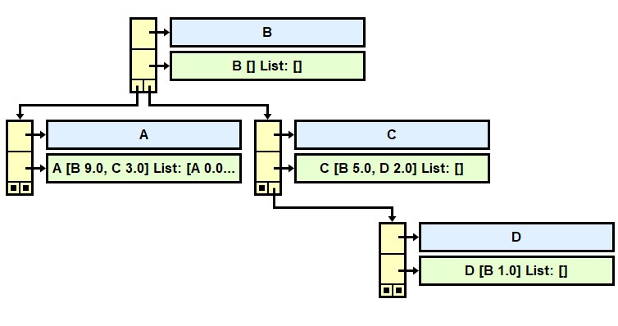

1

9

5

3

2

Unfortunately, the jGrasp picture does not show all the data in the PQelement . If we could see all the data stored at wVertex "A", we would see:

A [B 9.0, C 3.0] List: [A 0.0 previous: null, B 6.0 previous: D, C 3.0 previous: A, D 5.0 previous: C]

One of your tasks is re-write the toString in PQelement to show the word "previous: " and to display the previous field.

Suppose Dijkstra's Algorithm produces this result in the "A" wVertex:

A [B 9.0, C 3.0] List: [A 0.0 previous: null, B 6.0 previous: D, C 3.0 previous: A, D 5.0 previous: C]

Then what is the actual path from "A" to "B"? __________Write the code below.

Special case: if a vertex has no path to it, return an empty List.

public List<String> getShortestPathTo(wVertex start, wVertex end)   
 {

}

In the actual Lab07, we will run Dijkstra’s Algorithm on the weighted graph of our cities.

**4** Pierre

**2** Peoria

2

3

5

3

**0** Pendleton

**5** Pittsburgh

8

**7** Pueblo

**6** Princeton

2

3

10

4

5

**3** Phoenix

5

**1** Pensacola

What is the shortest distance from Pueblo to Pendleton?____ What path?___________________

What is the shortest distance from Pittsburgh to Phoenix?____ What path? _________________

**Assignment**

Open your old AdjListWeighted. Comment in and implement AdjListWeightedInterfaceWithCities.

Update toString method in the PQelement class so it also displays the previous field.

getShortestPathTo returns the actual path from source to target.

The readData method reads the data from two text files, the names (cities.txt) and the weights (cityEdgeListWeighted.txt.)

The driver is Dijkstra_7_Driver.java. You will turn in AdjListWeighted.

**Extension**

Replace the priority queue with a queue, list, set, or your own heap. Get it to work.

**Big-O Analysis**

The Big-O for Dijkstra's Algorithm depends critically on how quickly you select the next vertex. Our code used a priority queue. Java's priority queue, as you may recall, is implemented by a *heap*. Since searching through a heap is O(log V), our Dijkstra code performs in O(V*E*log V). If you use a regular *queue, list, or set,* Dijkstra’s algorithm requires a repeated linear search of all the vertices, resulting in O(V2 *E).

**Sample Run**

Here is a sample run of Dijkstra_7_Driver:

Dijkstra's Algorithm with cities!  
Enter file of cities: cities  
Enter file of edges: cityEdgesWeighted  
Enter source: Pittsburgh  
   
The entire graph is:  
Pendleton [Pueblo 8.0] List: []  
Pensacola [Phoenix 5.0] List: []  
Peoria [Pueblo 3.0, Pittsburgh 5.0] List: []  
Phoenix [Pueblo 3.0, Pittsburgh 10.0] List: []  
Pierre [Pendleton 2.0] List: []  
Pittsburgh [Pensacola 4.0, Phoenix 10.0] List: [Pensacola 4.0 previous: Pittsburgh, Pendleton 17.0 previous: Pierre, Pierre 15.0 previous: Pueblo, Princeton Infinity, Pueblo 12.0 previous: Phoenix, Peoria Infinity, Phoenix 9.0 previous: Pensacola, Pittsburgh 0.0]  
Princeton [Princeton 5.0, Pittsburgh 2.0] List: []  
Pueblo [Pendleton 8.0, Pierre 3.0] List: []  
   
Data structure of the source vertex: Pittsburgh  
Pittsburgh [Pensacola 4.0, Phoenix 10.0] List: [Pensacola 4.0 previous: Pittsburgh, Pendleton 17.0 previous: Pierre, Pierre 15.0 previous: Pueblo, Princeton Infinity, Pueblo 12.0 previous: Phoenix, Peoria Infinity, Phoenix 9.0 previous: Pensacola, Pittsburgh 0.0]  
   
Distance from source to Pensacola: 4.0  
 path: [Pittsburgh, Pensacola]  
Distance from source to Pendleton: 17.0  
 path: [Pittsburgh, Pensacola, Phoenix, Pueblo, Pierre, Pendleton]  
Distance from source to Pierre: 15.0  
 path: [Pittsburgh, Pensacola, Phoenix, Pueblo, Pierre]  
Distance from source to Princeton: Infinity  
 path: []  
Distance from source to Pueblo: 12.0  
 path: [Pittsburgh, Pensacola, Phoenix, Pueblo]  
Distance from source to Peoria: Infinity  
 path: []  
Distance from source to Phoenix: 9.0  
 path: [Pittsburgh, Pensacola, Phoenix]  
Distance from source to Pittsburgh: 0.0  
 path: [Pittsburgh]

**Sample Run: 26 vertices, 676 randomly-weighted edges**

Dijkstra's Algorithm with cities!  
Enter file of cities: random1Names  
Enter file of edges: random1Weighted  
Enter source: B

**Compare your output to this (partial) output:**

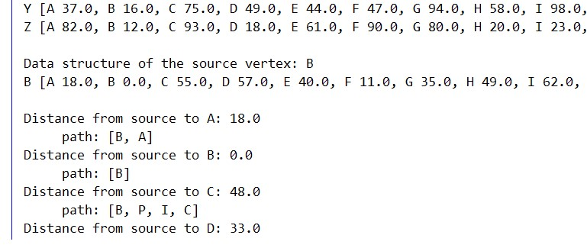

**Sample Run: 26 vertices, 676 randomly-weighted edges**

Dijkstra's Algorithm with cities!  
Enter file of cities: random2Names  
Enter file of edges: random2Weighted  
Enter source: C

**Compare your output to this (partial) output:**

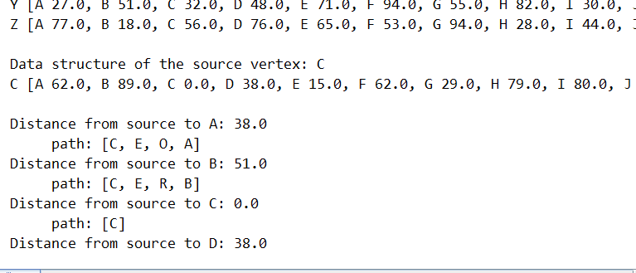

**Good Practice**

Trace Dijkstra's Algorithm on the Pittsburgh-Pensacola-Phoenix triangle. Show how the minimum-List are updated.

|  |  |  |  |
| --- | --- | --- | --- |
|  | Pittsburgh | Pensacola | Phoenix |
| start v=Pittsburgh |  |  |  |
| after v= |  |  |  |
| after v= |  |  |  |
| after v= |  |  |  |

Pittsburgh

4

10

Phoenix

5

Pensacola

Record the processing of the PQelements and how each minimum distance is calculated.

|  |  |  |  |  |  |
| --- | --- | --- | --- | --- | --- |
| Pit  0 |  |  |  |  |  |

Here is the priority queue pq:

|  |  |
| --- | --- |
|  |  |
|  |  |
|  |  |
|  |  |
|  |  |
|  |  |
|  |  |
|  |  |
|  |  |